JCO Client 如何套用 SAP Load Balance 機制

- JCO 連線參數:
- 共用:
JCO_CLIENT = 510
JCO_USER = RFCUSER
JCO_PASSWD = XXX
JCO_LANG = ZH
- 無 Load Balance 機制
JCO_ASHOST = 192.168.200.30
JCO_SYSNR = 00
- 有Load Balance 機制
JCO_MSHOST: sap-qas
JCO_R3NAME: QAS
JCO_GROUP: TCCRFC

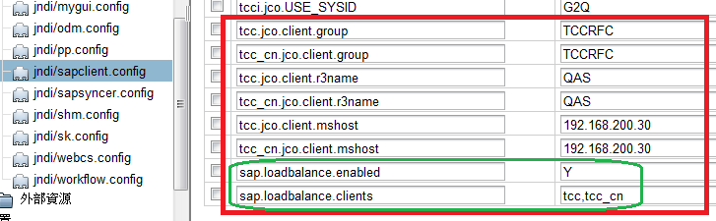

- sap.loadbalance.enabled : JCO是否啟用 SAP Load Balance 機制
- sap.loadbalance.client: 要應用的 SAP Load Balance機制的Client 代號

- OS通訊埠設定：
- Linux:
於 /etc/service 新增

sapmsQAS 3600/tcp # SAP QAS system message server port
sapdp00 3200/tcp # SAP QAS system dispatcher security port
sapgw00 3300/tcp # SAP QAS system gateway security port

- windows:
檔案: C:\Windows\sapmsg.ini
[Message Server]
QAS=192.168.200.30
檔案: C:\Windows\System32\drivers\etc\services
sapmsQAS 3600/tcp # SAP QAS system message server port
sapdp00 3200/tcp # SAP QAS system dispatcher security port
sapgw00 3300/tcp # SAP QAS system gateway security port

- Java 端程式修改：(Procurement portal 程式為例)
當有程式需呼叫 RFC 時，
@Resource(mappedName = "jndi/sapclient.config")
private Properties jndiConfig;

呼叫 com.tcci.sapproxy.jco.JCoUtils 中 getJCoProp(jndiConfig, “tcc”) 取出需要的設定;

public class JCoUtils {
..
// JCO連線參數結尾
protected static String[] JCO_PROP_POSTFIX = {"jco.client.lang",
"jco.client.passwd", "jco.client.user", "jco.client.client",
"jco.client.sysnr", "jco.client.ashost", "jco.destinationName",
"jco.destination.pool_capacity", "jco.destination.peak_limit",
"jco.client.mshost", "jco.client.group", "jco.client.r3name" // for sap load balance
};

private static final String SAP_LOAD_BALANCE_ENABLED = "sap.loadbalance.enabled";
private static final String SAP_LOAD_BALANCE_CLIENTS = "sap.loadbalance.clients";

public static Properties getJCoProp(Properties jndiConfig, String sapclientCode) {
Properties jcoProp = new Properties();

// 依 sapclientCode 取出需要的設定
…
// 有使用 SAP LOAD BALANCE 機制
if( jndiConfig.get(SAP_LOAD_BALANCE_ENABLED)!=null
&& jndiConfig.get(SAP_LOAD_BALANCE_ENABLED).equals("Y")
&& jndiConfig.get(SAP_LOAD_BALANCE_CLIENTS)!=null ){

String[] clients =
StringUtils.getTokens((String)jndiConfig.get(SAP_LOAD_BALANCE_CLIENTS), ",");

// 移除SAP單機連結設定
for(String key : clients){
jcoProp.remove(key+".jco.client.ashost");
jcoProp.remove(key+".jco.client.sysnr");

logger.debug("有使用 SAP LOAD BALANCE 機制 key = "+key);
}
}

return jcoProp;
}
}

